H.T No
Regulations:
A14

Sreenidhi Institute of Science and Technology
(An Autonomous Institution)
Code No: 4B203 Date: 26-Nov-2020 (FN)

B.Tech I-Year II-Semester External Examination, Nov/Dec - 2020 (Supplementary)
ENGINEERING MECHANICS (ME)

Time: 2 Hours Max.Marks:70

Note: a) No additional answer sheets will be provided.
b) All sub-parts of a question must be answered at one place only, otherwise it will not be valued.
c) Missing data can be assumed suitably.

ANSWER ANY 5 OUT OF 8 QUESTIONS. EACH QUESTION CARRIES 14 MARKS.

1. |  | A man weighing 750 N stands at the middle of a uniform ladder weighing 250 N as shown in Fig. Assuming that the floor and the wall are absolutely smooth and slipping is prevented by the connecting string DE, determine the tension in the string and the reactions at the floor and the wall.  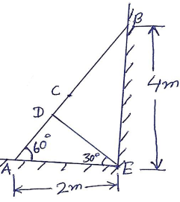 | [14M]
2. |  | Determine the force P required to start the wedge as shown in Fig. The angle of friction for all surfaces of contact is 15⁰. Neglect weight of wedge.  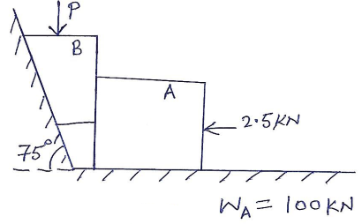 | [14M]
3. |  | Determine the forces in all the members of the frames shown in Fig.  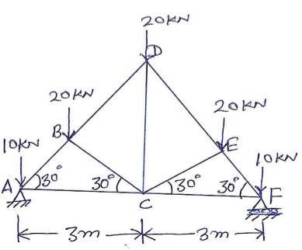 | [14M]
4. |  | Determine the position of the centroid of the plane figure as shown in Fig.  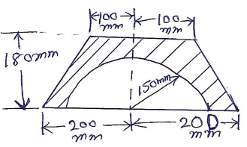 | [14M]
5. |  | Find the moment of inertia of the I- section shown in Fig. about the centroidal axes.  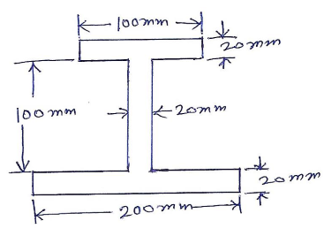 | [14M]
6. |  | A 3000 N block starting from rest as shown in Fig. slides down a 50⁰ incline. After moving 2m it strikes a spring whose modulus is 20 N/m. If the coefficient of friction between the block and the incline is 0.2, determine the maximum deformation of the spring and the maximum velocity of the block.  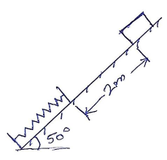 | [14M]
7. |  | Two smooth spheres each of radius 100 mm and weight 100 N, rest in a horizontal channel having vertical walls, the distance between which is 360 mm. Find the reaction at the points of contacts A, B, C and D shown in Fig.  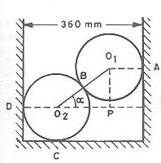 | [14M]
8. |  | Determine the moment of inertia of a solid sphere of radius R about its diametral axis. | [14M]

-- 00 -- 00 –

